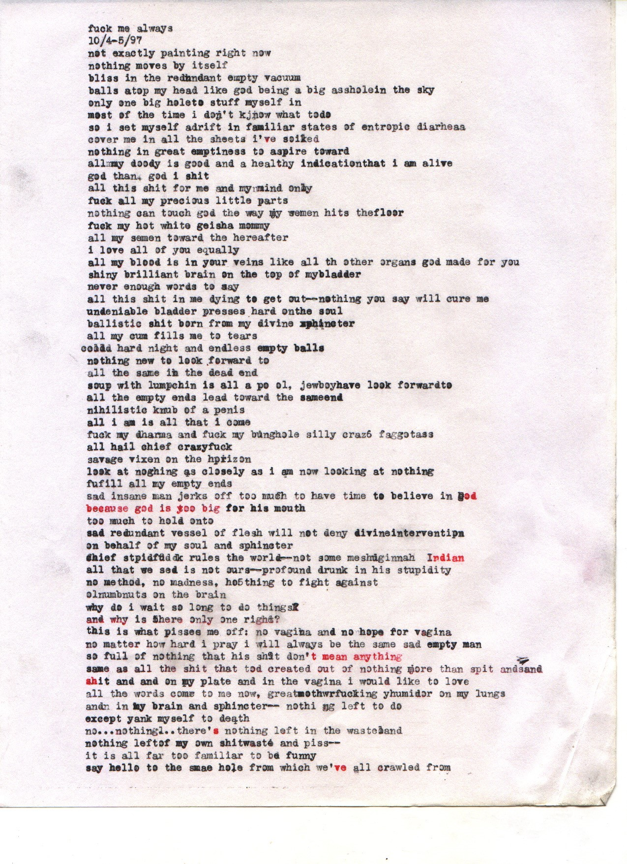
fuck me always
10/4-5/97
not exactly painting right now
nothing moves by itself
bliss in the redundant empty vacuum
balls atop my head like god being a big asshole in the sky
only one big holeto stuff myself in
most of the time I don’t know what to do
as I set myself adrift in familiar states of entropic diarhhea
cover me in all the sheets I’ve soiled
nothing in great emptiness to aspire toward
all my doody is good and a healthy indicationthat I am alive
god thank god I shit
all this shit for me and my mind only
fuck all my precious little parts
nothing can tough god the way my semen hits the floor
fuck my hot white geisha mommy
all my semen toward the hereafter
I love all of you equally
all my blood is in your veins like all the other organs
god made for you
shiny brilliant brain on the top of mybladder
never enough words to say
all this shit in me dying to get out--nothing you say
will cure me
undeniable bladder presses hard on the soul
ballistic shit born from my divine sphincter
all my cum fills me to tears
cold hard night and endless empty balls
nothing new to look forward to
all the same in the dead end
soup with lumpchin is all a poor jewboyhave look forwardto
all the empty ends lead toward the sameend
nihilistic knob of a penis
all I am is all that I come
fuck my dharma and fuck my bunghole silly crazy faggotass
all hail chief crazyfuck
savage vixen on the horizon
look at nothing as closely as I am now looking at nothing
fulfill all my empty ends
sad insane man jerks off too much to have time to believe
in god
because god is too big for his mouth
too much to hold onto
sad redundant vessel of flesh will not deny divineintervention
on behalf of my soul and sphincter
chief stupidfuck rules the world—not some meshuginah Indian
all that we see is not ours—profound drunk in his stupidity
no method, no madness, nothing to fight against
olnumbnuts on the brain
why do I wait so long to do things?
and why is there only one right?
this is what pisses me off: no vagina and no hope for vagina
no matter how hard I pray I will always be the same sad
empty man
so full of nothing that his shit don’t mean anything
same as all the shit that god created out of nothing more
than spit andsand
shit and and on my plate and in the vagina I would like to love
all the words come to me now, greatmotherfucking humidor
on my lungs
and in my brain and sphincter—nothing left to do
except yank myself to death
no…nothing…there’s nothing left in the wasteland
nothing leftof my own shitwaste and piss—
it is all far too familiar to be funny
say hello to the same hole from which we’ve all crawled from

