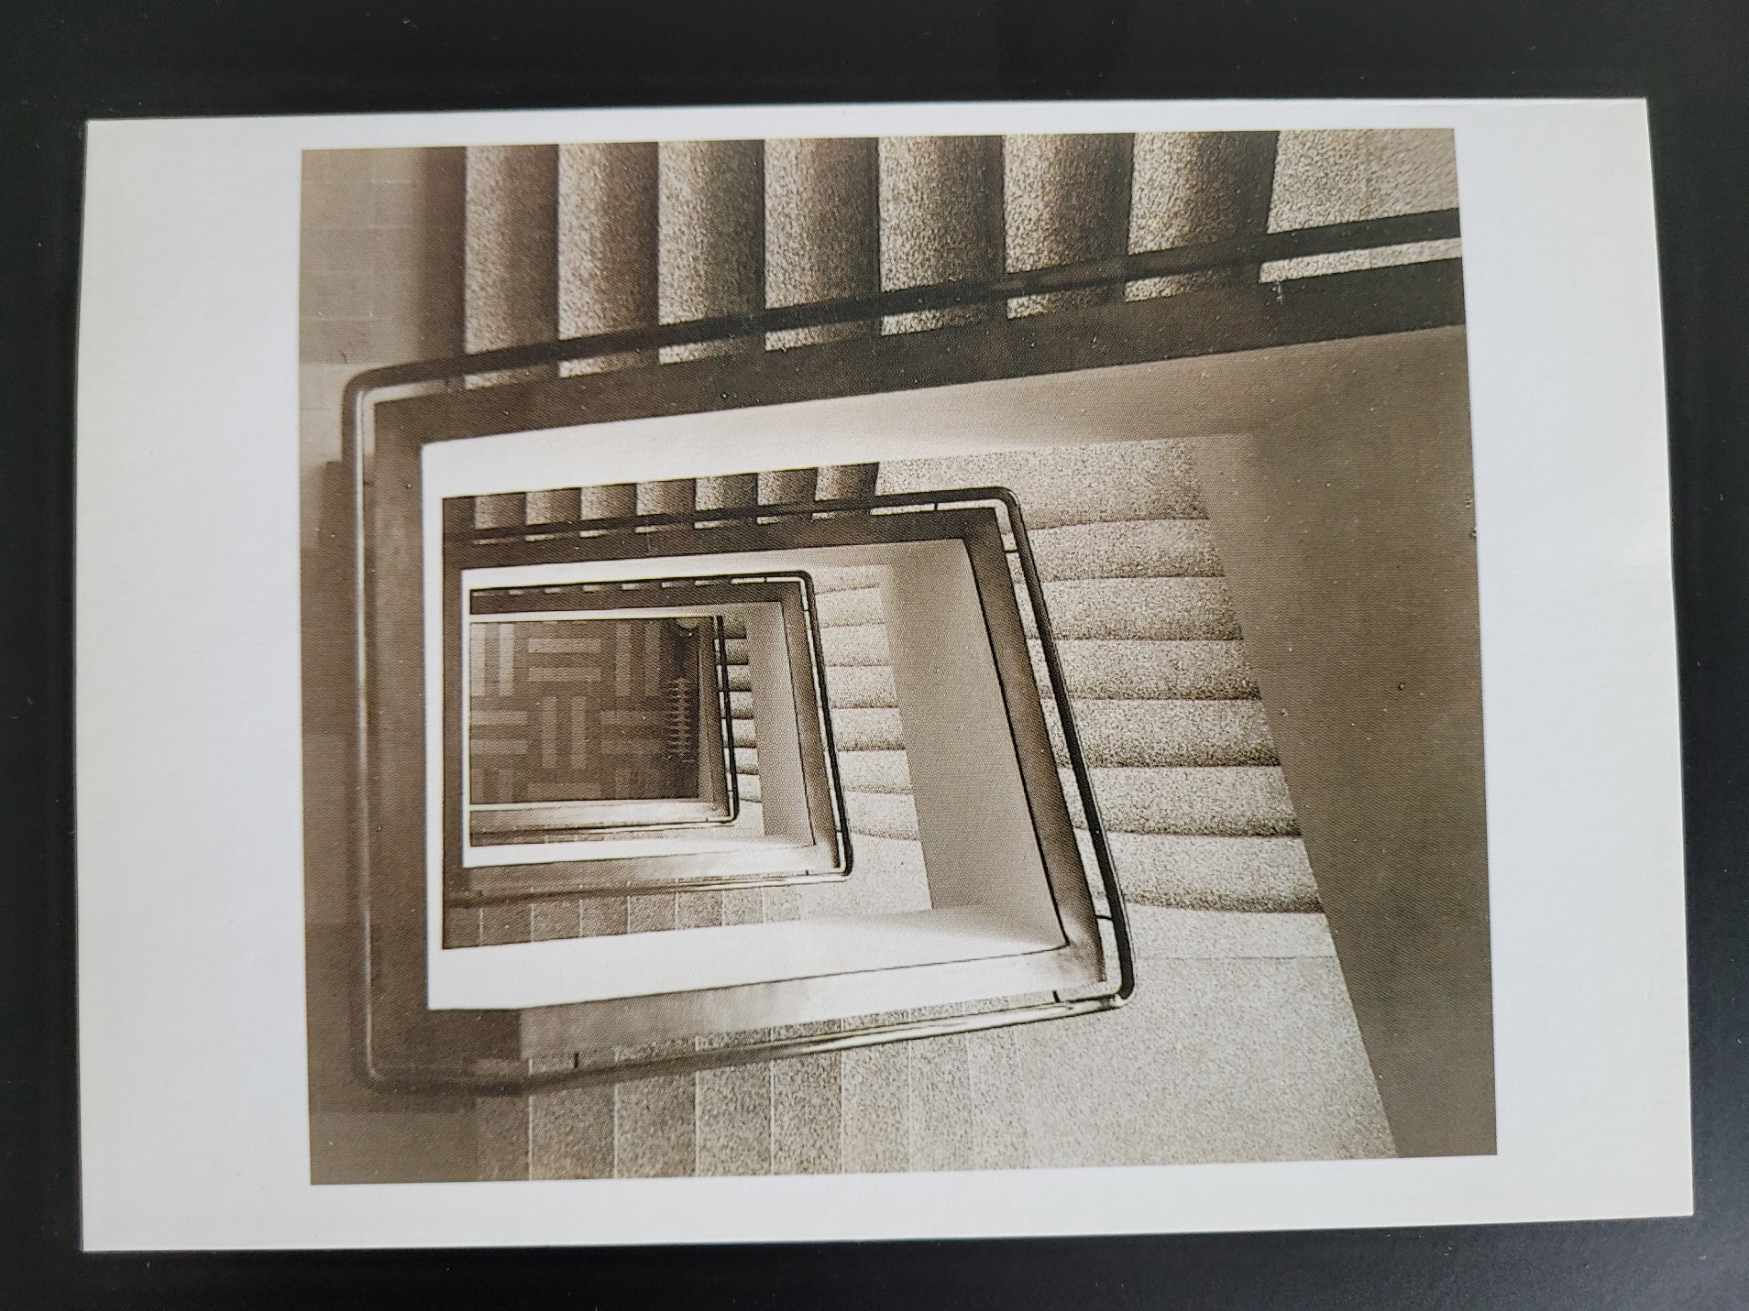

Stairstich

Infinite staircase swallows itself

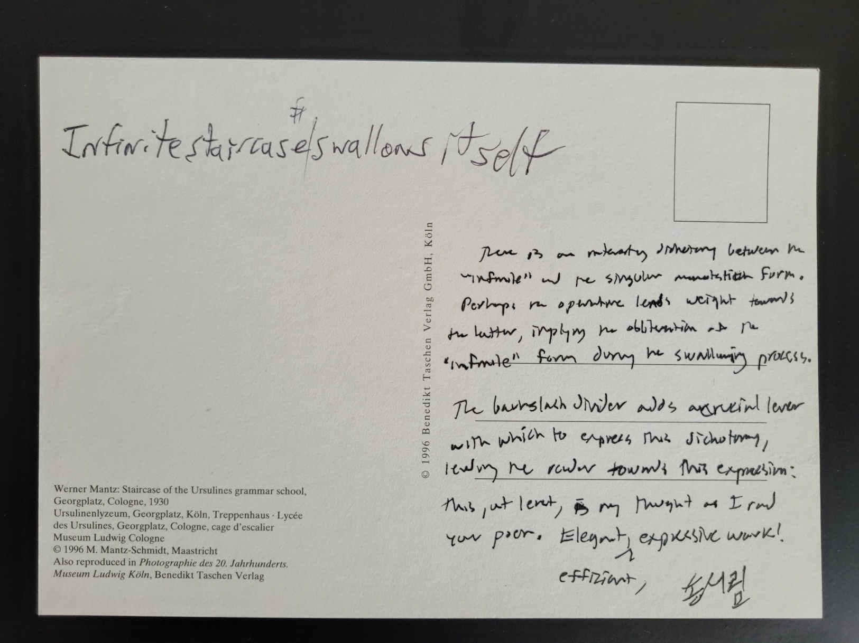

Stairstich Squared

Infinite
s
t
a
f i
l r
e c
s a
t s
i e
swollaws

