Price: Eight bits
or $1 USD

Apocalyptic Sunday Fragments
and Other Astral Debris

by

Howard N Kaplan

Howard N Kaplan

Collected Works

Poetry
Progressive Regression (1982)
Memories of the East River and Other Streams of Consciousness (1984)
Strength and Suffering (1985)
Apocalyptic Sunday Fragments and Other Astral Debris (1987)
Too Drunk To Swim (1990)
Soul Spasms (1998)

Short Fiction
Hell Visions and Other Wet Dreams (1983)
Alive and Well on The Road to Self-Destruction and Other Paths of Righteous Indulgence (1987)

Novels
Shouting at the Storm (1981)
The Cow Tripped Over The Moon (1983)

Novellas
The Adventures of Jacques LaRaque (1982)

Plays
Sir Realism and Other Plays (1979)
Captain Chihuahua and His Flamingo Brigade (1983)

Pseudo Religious Codex
The Book of the Great Fish (1986)

Ephemera
Notes From Naropa 1994: From The Jack Kerouac School of Disembodied Poetics (1994)
Typewriter Spew (collected 2024)
Unadulterated Spew (1966-present)

The characters and incidents in this volume are entirely the products of the author’s imagination and have no relation to any person or event in real life. The contents herein are not designed for consumption by children, animals, or sensitive adults.

First electronic and second print edition
© 2024 Private Sanity Publications
(a division of Private Sanity Enterprises)
and Howard N Kaplan
privatesanity.com
All Rights Reserved

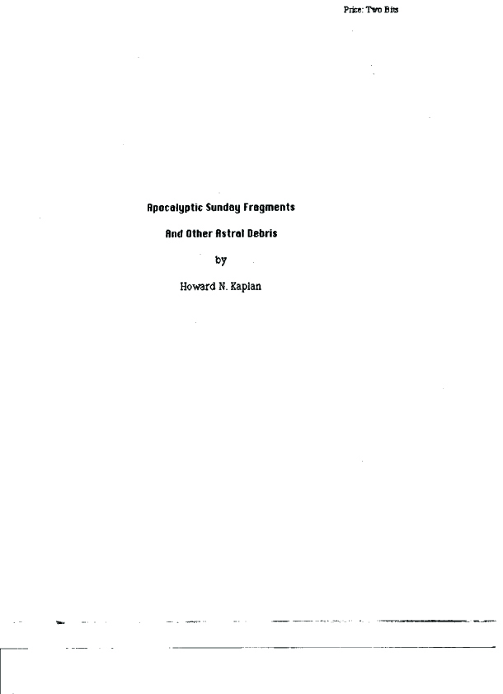
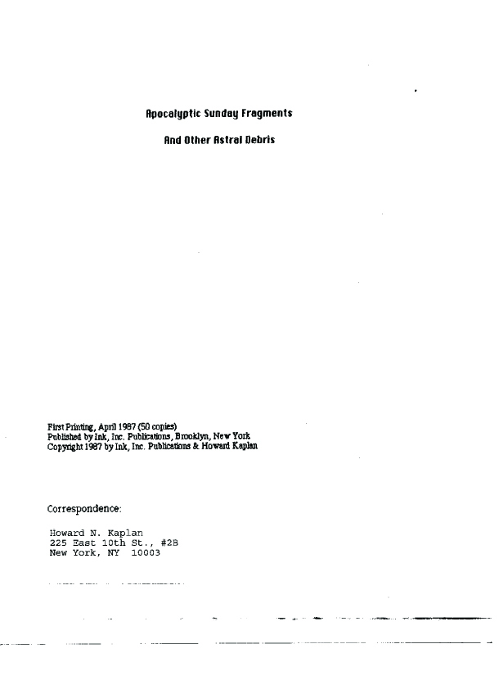
CONTENTS

Apocalyptic Sunday Fragments 7

Athanasia 9

I Sit Dumb As You Cast the Stone
Upon the Water 12

Sparklesweet Suckle Delight 15

Wisdom 17

Child of the Sun 19

Morning Sunflower Speaks 20

How Am I 23



